# Lab 6

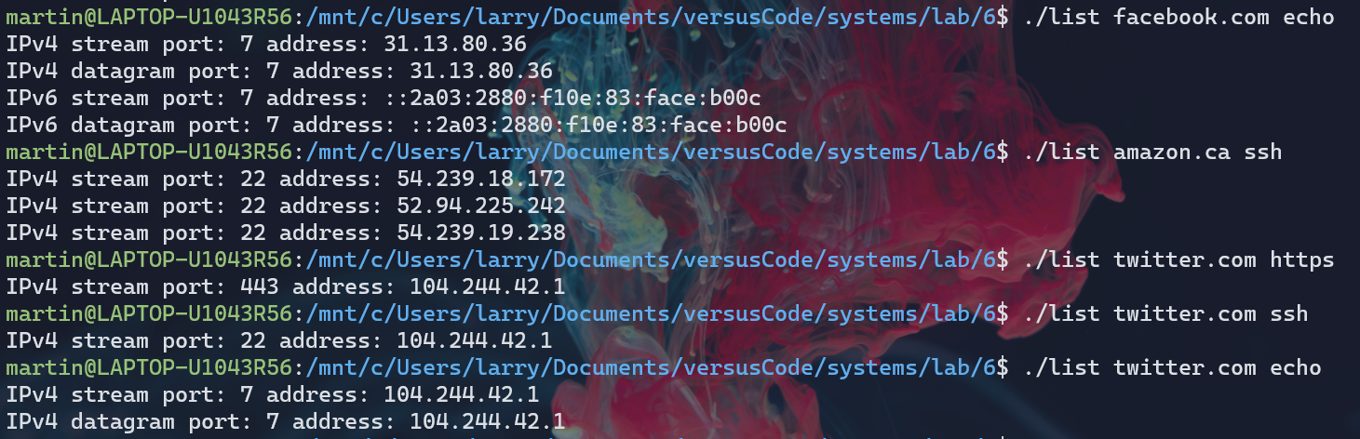

# Makefile

CFLAGS = -Wall -g

run: list.o

cc -o list list.o

clean:

rm list list.o